Name :Ma Phyo Zin Mar

Case Study5

**Test1**

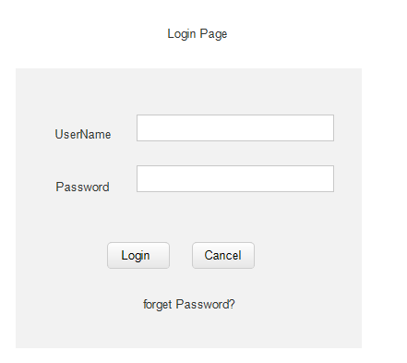

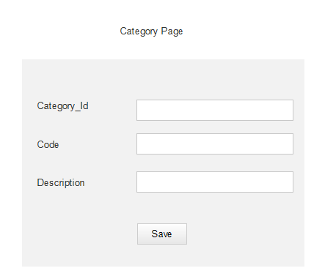

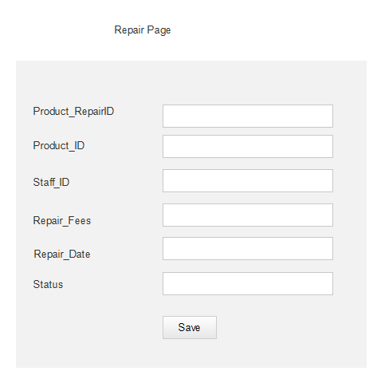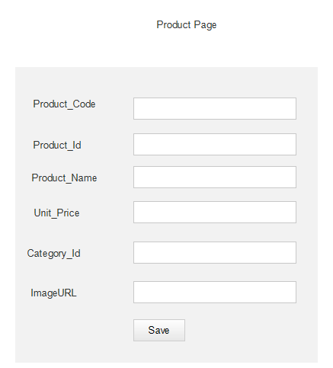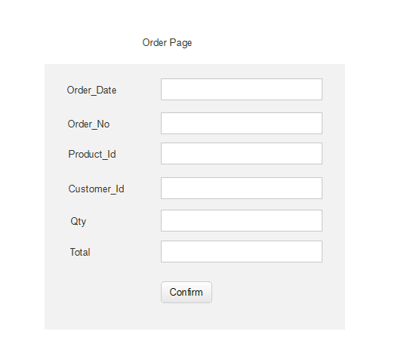

Task2

Development plan

* To save order record in the system
* To add new category and add new product in the system
* To view existing category,product and order record according daily or monthly.
* To use account (Admin&Staff) to enter the system.

Deployment plan

* Have to use laptop,phone,Pc and desktop.
* Computer window 10 and above.
* Version 8.0 and above

Task3

Testing type of System

* The system can save stock and order record into the database
* The system can support al l the Pc and os.
* The system can create the backup database file after each transaction
* The system can use easily and data integrity
* Only admin can change secure access of confidential data
* Username and password are encrypted

Task4

* Security (may be separated between admin and staff)
* Authorization
* Data integrity
* Database backup

Case Study6

Task1

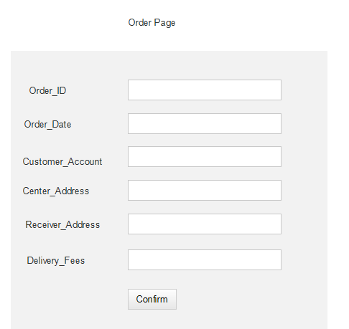

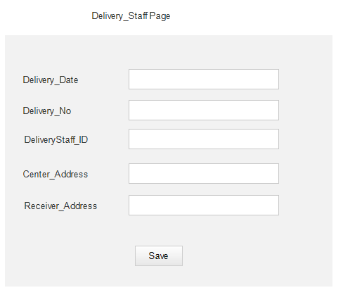

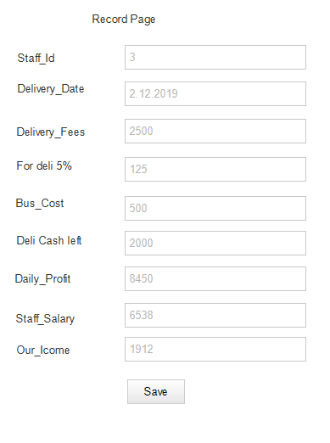

Task2

Development plan

* To save order record in the system
* To calculate cost, staff’s salary, income and profit monthly or weekly.
* To view existing order record according daily or monthly.
* To save staff’s details and customer details in the system

Deployment plan

* Have to use laptop,phone,Pc and desktop.
* Computer window 10 and above.
* Version 8.0 and above
* May have facebook messenger account to accept order

Task3

* The system can save stock and order record into the database
* The system can support al l the Pc and os.
* The system can create the backup database file after each transaction
* The system can use easily and data integrity
* The system can restrict location and customer can select fee to order

Task4

* Security (payment for bank acc)
* Authorization
* Data integrity
* Database backup